9-PIN S-D FLAT LASER COMMUNICATION, COMM-1, COMM-2 CABLE

- PARTS:

QUANTITY: PART #: NOMENCLATURE: LENGTH:

1 PER MACHINE 17635-4 CONNECTOR, PLUG, D-SUB, 9-PIN N/A

1 PER MACHINE 17636-4 CONNECTOR, RECEPTACLE, D-SUB N/A

1 PER MACHINE 19220-30 CABLE, FLAT RIBBON, 28 AWG 26 INCHES

- ASSEMBLY:

- CUT THE CABLE SO THAT YOU HAVE THE COLORS BROWN THROUGH WHITE IN A NINE CONDUCTOR RIBBON.

B. ASSEMBLE THE CONNECTORS SO THAT PIN 1 ALIGNS WITH THE BROWN WIRE, ACCORDING TO DIAGRAM 1.
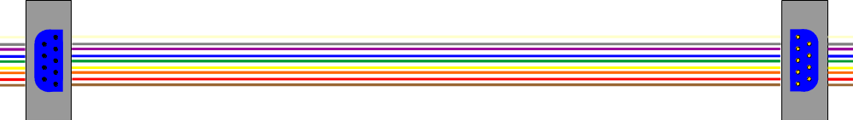

DIAGRAM 1

